Paired t-test Using SAS
(commands= finan_paired.sas)

This command file uses the data set, PULSE, which is imported from the PULSE.XLS data set, using Proc Import.

/**************************************
PAIRED T-TEST

FILENAME: DAY2_FINAN_PAIRED.SAS
****************************************/
options nodate nofmterr pagno=1;
title;
options FORMCHAR="|----|+|---+=|-/\<>*";

/*IMPORT PULSE DATA USING PROC IMPORT*/
PROC IMPORT OUT= WORK.PULSE
DATAFILE= "C:\temp\labdata\PULSE.XLS"
DBMS=EXCEL REPLACE;
SHEET="pulse";
GETNAMES=YES;
MIXED=NO;
SCANTEXT=YES;
USEDATE=YES;
SCANTIME=YES;
RUN;

proc format lib=work;
value ranfmt 1="Ran"
2="Didn't Run";
value sexfmt 1="Female"
0="Male";
value minfmt 1="Minority"
0="White";
value actfmt 1="Low Activity"
2="Medium Activity"
3="High Activity";
run;

/*PROC CONTENTS TO CHECK DATA*/
title "Pulse Data Set";
proc contents data=pulse varnum;
run;

Pulse Data Set
The CONTENTS Procedure
Data Set Name WORK.PULSE Observations 92
Member Type DATA Variables 8
Engine V9 Indexes 0
Created Monday, August 21, 2006 09:27:51 PM Observation Length 64
Last Modified Monday, August 21, 2006 09:27:51 PM Deleted Observations 0
Protection Compressed NO
Data Set Type Sorted NO
Label
Data Representation WINDOWS_32
Encoding wlatin1 Western (Windows)

Variables in Creation Order
# Variable Type Len Label
1 pulse1 Num 8 pulse1
2 pulse2 Num 8 pulse2
3 ran Num 8 ran
4 smokes Num 8 smokes
5 sex Num 8 sex
6 height Num 8 height
7 weight Num 8 weight
8 activity Num 8 activity

/*CALCULATE PULSEDIFF VARIABLE IN A DATA STEP*/
data newpulse;
set pulse;
pulsediff = pulse2 - pulse1;
run;

/*CHECK NORMALITY OF PULSE DIFFERENCE FOR LEVELS OF RAN*/
title "Check distribution of PULSEDIFF, and one-sample t-test";
proc univariate data=newpulse normal;
class ran;
format ran ranfmt.;
var pulsediff;
run;

Check distribution of PULSEDIFF, and one-sample t-test
The UNIVARIATE Procedure
Variable: pulsediff
ran = Ran

Tests for Location: Mu0=0
Test -Statistic- -----p Value------
Student's t t 7.435276 Pr > |t| <.0001
Sign M 15 Pr >= |M| <.0001
Signed Rank S 286 Pr >= |S| <.0001

Tests for Normality
Test --Statistic--- -----p Value------
Shapiro-Wilk W 0.950493 Pr < W 0.1173
Kolmogorov-Smirnov D 0.148201 Pr > D 0.0493
Cramer-von Mises W-Sq 0.11509 Pr > W-Sq 0.0711
Anderson-Darling A-Sq 0.678521 Pr > A-Sq 0.0738

The UNIVARIATE Procedure
Variable: pulsediff
ran = Didn't Run

Tests for Location: Mu0=0
Test -Statistic- -----p Value------
Student's t t -0.19101 Pr > |t| 0.8492
Sign M -2.5 Pr >= |M| 0.5327
Signed Rank S -30 Pr >= |S| 0.6979

Tests for Normality
Test --Statistic--- -----p Value------
Shapiro-Wilk W 0.931434 Pr < W 0.0031
Kolmogorov-Smirnov D 0.174118 Pr > D <0.0100
Cramer-von Mises W-Sq 0.265908 Pr > W-Sq <0.0050
Anderson-Darling A-Sq 1.475438 Pr > A-Sq <0.0050

/*PAIRED t-test OF PULSE2 vs. PULSE1*/
title "Paired t-test of Pulse2 vs. Pulse1";
proc ttest data=newpulse;
paired pulse2*pulse1;
run;

Paired t-test of Pulse2 vs. Pulse1
The TTEST Procedure

Statistics
Lower CL Upper CL Lower CL Upper CL
Difference N Mean Mean Mean Std Dev Std Dev Std Dev Std Err
pulse2 - pulse1 92 4.3406 7.1304 9.9203 11.766 13.471 15.759 1.4045

T-Tests
Difference DF t Value Pr > |t|
pulse2 - pulse1 91 5.08 <.0001

/*REDO PAIRED t-test FOR EACH LEVEL OF RAN*/
proc sort data=newpulse;
by ran;
run;

title "Paired t-test of Pulse2 vs Pulse1 by RAN";
proc ttest data=newpulse;
by ran;
format ran ranfmt.;
paired pulse2*pulse1;
run;
Paired t-test of Pulse2 vs Pulse1 by RAN

------------------------------------------- ran=Ran ------------------------------------------
The TTEST Procedure
Statistics

Lower CL Upper CL Lower CL Upper CL
Difference N Mean Mean Mean Std Dev Std Dev Std Dev Std Err
pulse2 - pulse1 35 13.745 18.914 24.084 12.173 15.05 19.718 2.5439

T-Tests
Difference DF t Value Pr > |t|
pulse2 - pulse1 34 7.44 <.0001

--------------------------------------- ran=Didn't Run ----------------------------------------

The TTEST Procedure
Statistics

Lower CL Upper CL Lower CL Upper CL
Difference N Mean Mean Mean Std Dev Std Dev Std Dev Std Err
pulse2 - pulse1 57 -1.209 -0.105 0.9987 3.5126 4.1605 5.1039 0.5511

T-Tests
Difference DF t Value Pr > |t|
pulse2 - pulse1 56 -0.19 0.8492

proc sort data=newpulse;
by ran;
run;
goptions reset=all;
goptions device=win target=winprtm;
title "Boxplot";
proc boxplot data=newpulse;
plot pulsediff * ran / boxstyle=schematic;
format ran ranfmt.;
run;

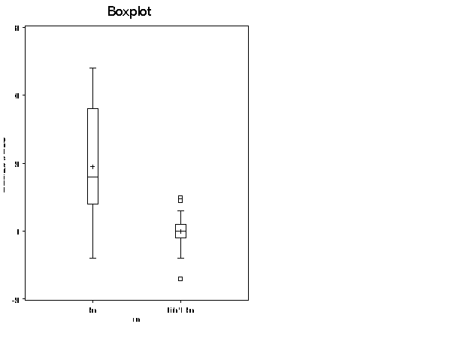
title "Independent Samples t-test on Pulsediff";
proc ttest data=newpulse;
class ran;
format ran ranfmt.;
var pulsediff;
run;

The TTEST Procedure

Statistics

Lower CL Upper CL Lower CL Upper CL
Variable ran N Mean Mean Mean Std Dev Std Dev Std Dev Std Err

pulsediff Ran 35 13.745 18.914 24.084 12.173 15.05 19.718 2.5439
pulsediff Didn't Run 57 -1.209 -0.105 0.9987 3.5126 4.1605 5.1039 0.5511
pulsediff Diff (1-2) 14.832 19.02 23.207 8.5669 9.815 11.492 2.1077

T-Tests
Variable Method Variances DF t Value Pr > |t|
pulsediff Pooled Equal 90 9.02 <.0001
pulsediff Satterthwaite Unequal 37.2 7.31 <.0001

Equality of Variances
Variable Method Num DF Den DF F Value Pr > F
pulsediff Folded F 34 56 13.08 <.0001

/*NON-PARAMETRIC WILCOXON RANK SUM TEST*/
title "Wilcoxon Rank Sum test on Pulsediff";
proc npar1way data=newpulse wilcoxon;
class ran;
format ran ranfmt.;
var pulsediff;
run;

Wilcoxon Rank Sum test on Pulsediff
The NPAR1WAY Procedure
Wilcoxon Scores (Rank Sums) for Variable pulsediff
Classified by Variable ran

Sum of Expected Std Dev Mean
ran N Scores Under H0 Under H0 Score
--------------------------------------------------------------------------
Ran 35 2440.50 1627.50 123.660110 69.728571
Didn't Run 57 1837.50 2650.50 123.660110 32.236842

Average scores were used for ties.

Wilcoxon Two-Sample Test
Statistic 2440.5000
Normal Approximation
Z 6.5704
One-Sided Pr > Z <.0001
Two-Sided Pr > |Z| <.0001

t Approximation
One-Sided Pr > Z <.0001
Two-Sided Pr > |Z| <.0001
Z includes a continuity correction of 0.5.

Kruskal-Wallis Test
Chi-Square 43.2237
DF 1
Pr > Chi-Square <.0001

